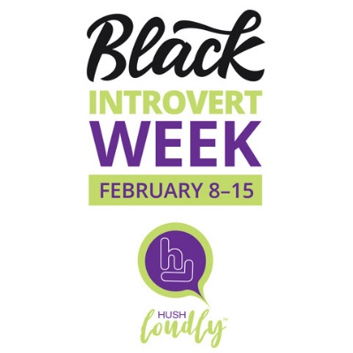

Tuesday, 2/8/22
BLACK INTROVERT RESOURCE GUIDE
Keni Dominguez and Jeri Bingham have developed the first Black Introvert Resource Guide.
It is a list of resources (articles, podcasts, books, products) created for, or about being Black and introverted. Delve more into our unique culture and community by listening to the stories, voices and challenges of other Black introverts. Source: Hushloudly.com

PANEL: The Introverted Black Woman: We’re not a Monolith
Panelists Keni Dominguez, Sylvia L. Jones, Collette Brown Rogers, Christina Steed and Jeri Bingham will talk about societal expectations, misguided stereotypes and how they move through misunderstandings to succeed in their careers. They will talk about how they’ve learned to make their natural demeanors work for them, and why organizations’ IDEA work must include Black introverted women.
Moderated by Mr. Darrious Hilmon
Register here.

Thursday, 2/10/22
BLACK INTROVERT BUSINESS DAY
Introverts often market for everyone else, but have a hard time marketing themselves. Use this day to promote your business, products, articles, photography, podcasts, art, ideas, etc., and share with the world.
1. Tag @hushloudly so that we also can share.
2. Use #BlackIntrovertWeek.

Saturday, 2/12/22
INTROVERT TEE SHIRT DAY
Use your voice without saying a word. It’s time for us to be seen! For all introverts and introvert allies, post and share your introvert-themed merch.
1. Tag @hushloudly so that we also can share.
2. Use #BlackIntrovertWeek.

Monday, 2/14/22
Valentine’s Day
1. On V-Day, show love to your introverted spouse, parent, child, best friend/confidant, self.
2. Give the introverts in your life a little understanding, alone time, breakfast, a book, movie, candle, or something calming and relaxing.
3. Love yourself by honoring your need for solitude to recharge.

Tuesday, 2/15/22
Honor your introversion. Have compassion for yourself. Rest, relax, recharge.

XOXO
Love, Jeri
HushLoudly: Introverts Redefined

