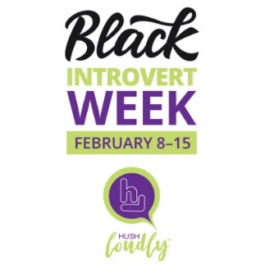

Wednesday, 2/8/23
Young, Gifted, Black and Introverted (YGB&I)
We’re kicking off Black Introvert Week 2023 with an artistic creation designed by Howard Griffith II.
HG2 is the youngest of HushLoudly’s Gamechangers: Introverts to Watch in 2023. Get his designs exclusively for Black Introvert Week at hushloudly.com/shop

Thursday, 2/9/23
BLACK INTROVERT-OWNED BUSINESS DAY
Introverts, use this day to promote your business, products, services, articles, photography, podcasts, art, ideas, etc., and share with the world. Tag @hushloudly / Use #BlackIntrovertWeek.

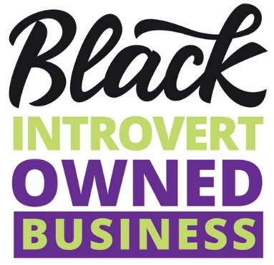

Saturday, 2/11/23
Introverting While Black: Lessons Learned
Hear from a panel of Black introverted influencers about how they move - - at work and at play in an extrovert-rewarding world. Leading voices Keni Dominguez, Richard Etienne, Lisa Hurley, Christina Steed join host and HushLoudly Founder Jeri Bingham to talk about how to play the game and win.

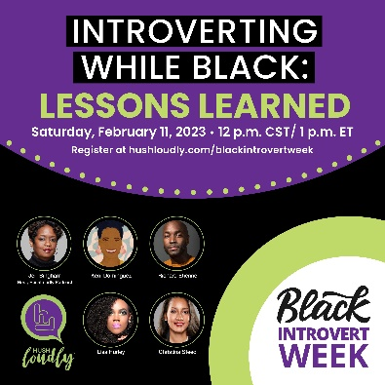

Register in advance for this meeting:
https://us02web.zoom.us/meeting/register/tZEsdeivqzsoHNAFri2RJg6L6o_Sb-h90p04

Tuesday, 2/14/23
Valentine’s Day
1. On V-Day, show love to your introverted spouse, parent, child, best friend, self.
2. Give the introverts in your life something to help them recharge:
Understanding, alone time, a nice meal, a book, movie date, or something they love.

Wednesday, 2/15/23
INTROVERT T-SHIRT DAY
Use your voice without saying a word. For all introverts and introvert allies, post and share a selfie in your introvert-themed merch.
1. Tag @hushloudly / Use #BlackIntrovertWeek.
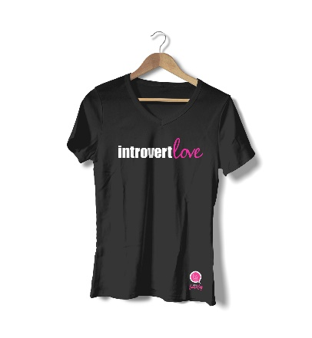
Find a variety of introvert gear at hushloudly.com/shop.

